


Seminar Series
Questions of Gender
Women Artists and Photographers between Archives and Research
curated by Martina Caruso, Elisa Genovesi, Giulia Ricozzi and Martina Rossi
as part of the M.A. on 19th and 20th Century Art History held by Prof. Raffaella Perna

Mademoiselle: Beyond Representation
with
TARA LONDI
9 April 2025 from 18.00 to 20.00
Aula di Geografia, Faculty of Letters and Philosophy, Sapienza University of Rome

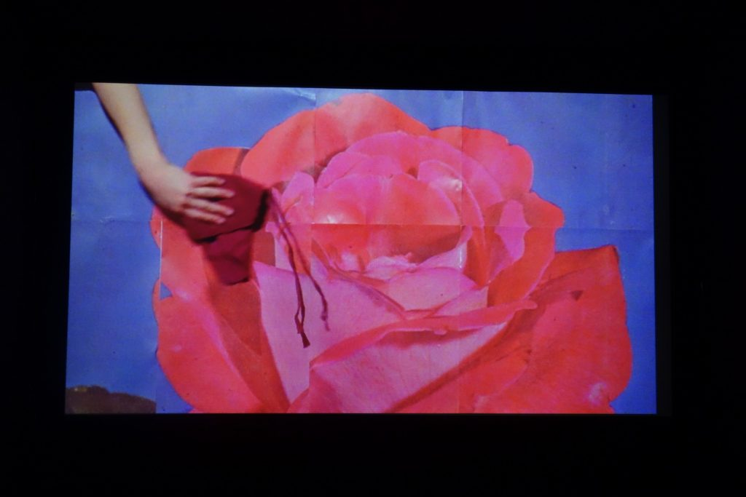

Sara Cwynar, Gold Rose

The event is part of the 2020 PRIN – Italian Feminist Photography
University of Bologna, Principal Investigator and Head of Research Unit: Prof. Federica Muzzarelli; University of Parma, Head of Research Unit: Prof. Cristina Casero; Sapienza University of Rome, Head of Research Unit: Prof. Raffaella Perna

